RASPBERRY MOUNTAIN TRAIL
WHAT: A hike for any interested woman of Impact Christian Church and friends;

Raspberry Mountain Trail is a 5.2 mile “out and back” trail located south of Divide on Hwy 67 and is rated as a moderate trail with an elevation gain of 1,013 feet. The trail is wide and smooth, most of it shaded by tall dark Colorado Spruce. The hike begins with short, steep switchbacks. Then, it levels out through a meadow and gentle forest floors. Eventually, you'll turn right on the forest road after crossing a creek. After a short uphill walk, you will turn left, leaving the Ring the Peak trail. From here, it is a relatively intense and mostly uphill climb to the top. Don’t let that description scare you ladies – we will maintain a pace that is comfortable for everyone.

WHEN: Saturday, Nov. 7th; We will start the hike promptly at 10:00 a.m. after the day begins to warm up. Bring a sack lunch, snacks or energy bars and lots of water. Dress in layers and wear hiking boots/comfortable hiking shoes.
This is NOT a race! Therefore, the entire hike (up to the top, lunch, taking pictures, relishing in God’s amazing creation, and hiking back down) will take several hours.
DIRECTIONS: Hwy 24 toward Divide from Woodland Park turn South/left onto CO 67 S (at the Divide light). Travel 4.3 miles and turn left on Teller CO Rd 62 and go 2.5 miles to the Raspberry Mountain Trailhead

PARKING We will meet at the trail head and depart for the hike promptly 10:00 a.m.

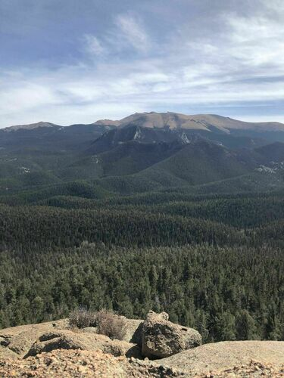
MORE INFORMATION: There’s no sign-up and no fee; just show up and enjoy the fellowship of “eternal sisters” in God’s glorious creation. Questions – contact Ericka Newland at 719-505-4335 or email her at erickanewland77@gmail.com

Weather is forecasted to be low 50’s and sunny.

