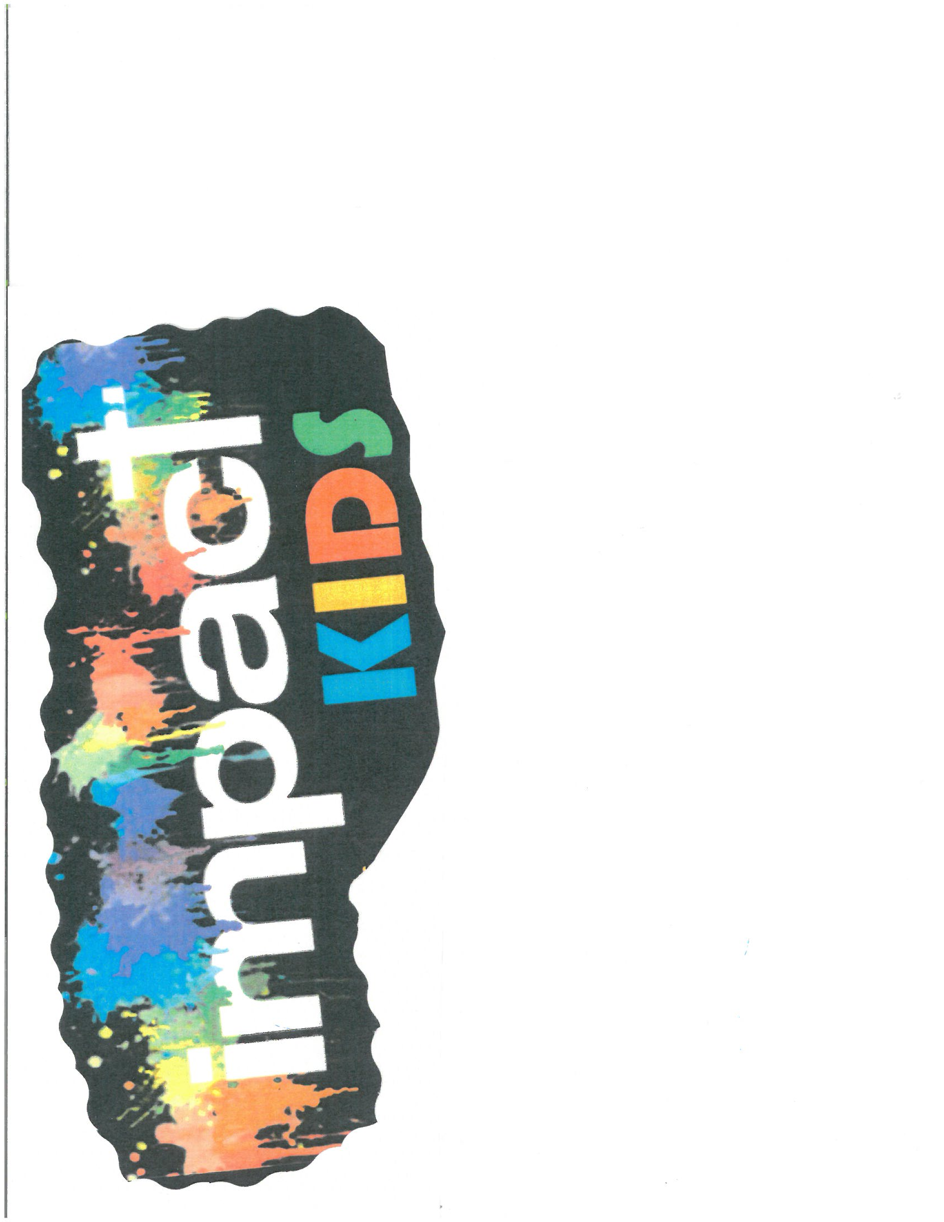

We are so excited to have your child attend Snow Camp with Impact Christian Church. We are looking forward to a fun filled weekend learning about Jesus, meeting new friends, and playing outside in God’s creation.

Things to Know:
1) We will be taking the church van. Joey Nilsen will be driving. We will leave the church at 4pm on Feb. 5th and return to the church on Feb. 6th around 3pm.
2) Please arrive on Friday at 3:30pm so we can make sure we have everything your child needs to head to Camp Como.
2) Cost is $55 per student. If a parent would like to come as a sponsor, cost is $30. All checks should be made out to Impact Christian Church.
3) Registration packet and medication forms must be filled out and returned by Jan. 31st, to Sandi Weece. Please return your packet as soon as possible if your child is planning to attend Snow Camp.

Items to Pack:
-sleeping bag and pillow
-winter coat, hats, gloves, snow pants, snow boots (clothing for outdoor snow play)
-Clothes for two days (have multiple socks in case they get wet) Have a trash bag to put dirty clothes in
-pj’s, slippers, sweatpants, toiletries (toothbrush, face cleaner, etc.)
-money for country store (if its open)
-Bible, Journal & Flashlight

Sandi Weece – 719-839-0157
Children’s Director
Joey Nilsen – 719-761-7671
Youth Minister

