UPCOMING WOMEN’S MINISTRY EVENTS
Impact Christian Church

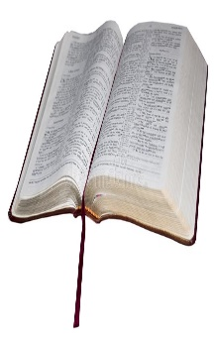
Bible Study – Proverbs 31, Thursdays, Aug. 25 – Nov. 10, Room 300 (hallway left of the auditorium; third door on the left); gather 10:15 a.m.– 12:00 noon. Bring notepaper, a pencil/pen, and a Bible. (No fee or pre-registration required; free childcare). Feel free to bring friends! Questions: Debi Blackwell, bearpaw333@gmail.com; 719-235-7144

Fused Glass Christmas Ornaments Workshop, Saturday, Sept. 10, 1:00 – 4:00 p.m.; There must be 12 participants pre-registered by Sept. 1 for this “reserved group” workshop to be held; 161 Quartz Rd., Florissant, CO; Space is limited to 16. Cost $65. Each participant will make 7 glass Christmas Ornaments. You are encouraged to “tithe” one of your ornaments for the Choices Christmas Bazaar. To register, phone the workshop facilitator, Anna Carrillo, at 719-761-7075 or anna@mountindesigns.com.
Parking is limited. Carpooling is STRONGLY encouraged. You are WELCOME to gather at Debi Blackwell’s house at 12:10 p.m. in your individual vehicle and carpool from there (203 Starlight Heights in Divide; phone 719-235-7144 to arrange carpooling)

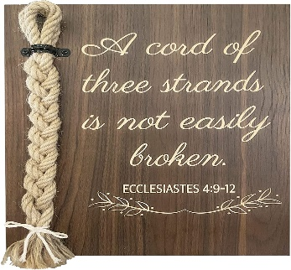
Women’s Retreat Saturday, Sept. 24, 9:00 a.m. – 3:30 p.m., Impact Church Café (downstairs); a FREE one-day retreat including fellowship, learning, worship, and fun. Registration Sundays, Sept. 4, 11, & 18 in the church lobby. For further information: Jan Peacock, janellhajek@yahoo.com, 719-200-1282.

Women’s Ministry Coordinator for Impact Church; emelvick@gmail.com; 719-641-1000

